

**Submitted by:**

Burhan Baig

**Referred to:**

Sir. Muhammad Affan

**Roll no:**

460945

Fundamentals of Programming

Home task 8

Task 1

int main() {

int size,Repvalue,mostrep,maxcount=0;

cout<<"Enter size of the array: "<<endl; cin>>size;

int reparray[size];

cout<<"\nEnter similar terms for the array: "<<endl;

for (int i=0;i<size;i++) {

cin>>reparray[i];

}

for (int i=0; i<size;i++) {

int count=1;

for (int j=i+1;j<size;j++) {

if (reparray[i]==reparray[j]) {

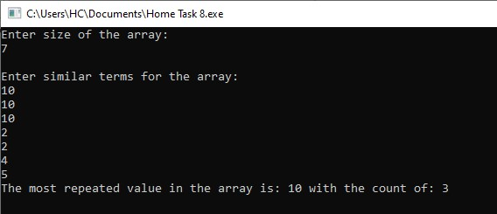

count++;

}

}

if (count>maxcount) {

maxcount=count;

mostrep=reparray[i];

}

}

cout<<"The most repeated value in the array is: "<<mostrep<<" with the count of: "<<maxcount<<endl;

return 0;

}

Task 2

int main () {

int a[8]= {13,15,17,9,99,77,65,43};

int minval=a[0],maxval=a[0];

for (int i=0;i<8;i++) {

if (a[i]>maxval) {

maxval=a[i];

}

}

for (int j=0;j<8;j++) {

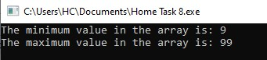if (a[j]<minval) {

minval=a[j];

}

}

cout<<"The minimum value in the array is: "<<minval<<endl;

cout<<"The maximum value in the array is: "<<maxval<<endl;

return 0;

}

Task 3

int main () {

int array[5];

cout<<"Enter different terms for the array: "<<endl;

for (int i=0;i<5;i++) {

cin>>array[i];

}

int temp;

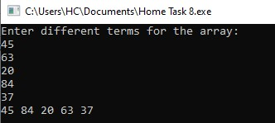temp=array[1];

array[1]=array[3];

array[3]=temp;

for (int j=0;j<5;j++) {

cout<<array[j]<<" ";}

return 0;

}